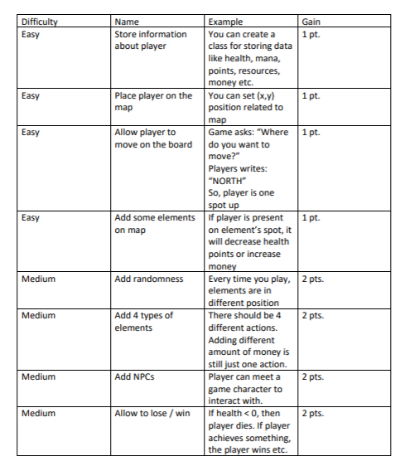







Enemies decrease life, score, energy

Walls decrease score, energy

NPC “Angela”, enemies, and

Food are placed randomly

Every time you play

Energy =0 -> go to shop

Money , Score ,Life =4



“Angela”, Can have small talk with her

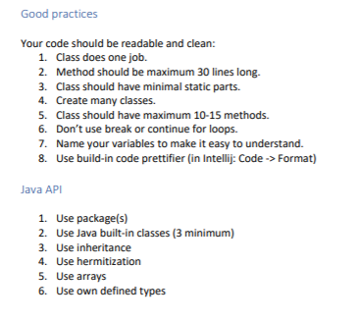

1. Yes
2. Yes
3. Yes
4. 7 classes
5. Max methods 11(in class Player)
6. Just “return”
7. Easy(at least for me)
8. Used
9. Used
10. Math, String and Scan
11. Yes
12. Yes
13. Yes